Instruction for the preparation of abstract papers; This is an example of the title for oral presentation.

Author A¹⁾, Author B^{2, *)} and Author C³⁾

1) Department, University
2) Department, University
Address, City, Zip Code, Country
e-mail: xxx@yy.edu
3) Department, University

* Corresponding author

Abstract
Abstract should be up to two pages, including tables and figures.
Abstract should briefly and clearly state the objective, methods, results and discussion, and conclusions of the work. Present your results in a logical sequence in text, tables and illustrations. Emphasize new and important aspects of the study and conclusions that are drawn from them.

Type the title in lowercase letters, except for the beginning and proper nouns. The title will be printed in the conference program; Do NOT Capitalize it Like This. The title should be in 14-point bold typeface, centered. Leave two blank lines below the title.

Type the authors’ names with 12-points plain typeface and include a superscript number (for example ¹⁾ and ²⁾ ) after each author’s name. The list of authors should be centered. Leave one blank line under the authors’ names.

Type affiliation of each author with 10-points plain typeface in the sequence of the superscript number. The required information is the department and university or the division and organization. The affiliations must be centered. The mailing address and e-mail address of the corresponding author should be provided.

The main body text should be typed single-spaced, justified with no indents. Please use a Times New Roman 12 pt font type. Insert one return between paragraphs. Do not exceed the dimensions given in this format.

Keywords: Three keywords separated by; semi-colons.

Table 1 This is a style for table titles. “Table 1, 2 etc” should be in bold. Table captions should appear above tables.
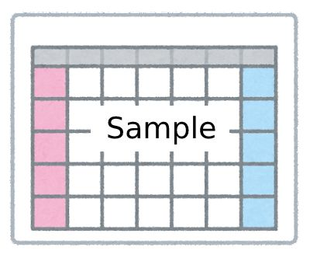

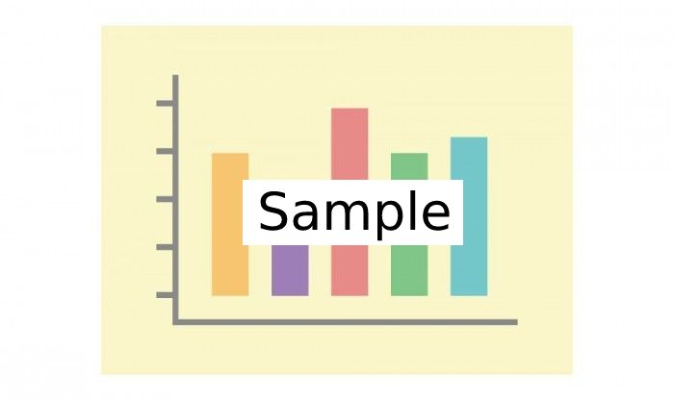

Figure 1 This is a style for figure legends. “Figure 1, 2 etc” should be in bold. Figure legends should appear below figures.

Notes (Delete this before submission):
- Please do not change the page margin of this template.
- The maximum length of the paper should not exceed 2 pages.
- Please mark the corresponding author with an asterisk.
- When you upload an abstract file, Google Form will automatically add your name to the end of the file name.

